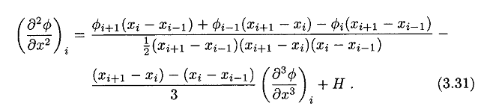

From “Computational Methods For Fluid Dynamics” by Ferziger & Peric (2002)

Assume Δxi is the grid size from ‘i’ to ‘i+1’, then the discretized form is,



The discretized form of the Poisson equation is:



The coefficient for PETSc:



The final form is:

