Suggestions for data storage improvements

Solution1

Move management of DataDescriptions to the DataStore.
If the DataStore is responsible for managing the list of DataDescriptions, persistence can be controlled by the DataStore and we would avoid redundant code used to manage DataDescriptions used by both VenueClient and Venue.

Remove the callback class
If we move the list of DataDescriptions from the Venue to the DataStore, Venue methods used to manage DataDescriptions such as AddData, GetData, and UpdataData should be moved from Venue to DataStore. Current DataStore code can then simply change venue callbacks (or VenueClient callbacks for personal data) to internal calls.

Use the EventClient in the DataStore
The AddData, GetData, and UpdateData venue methods are responsible for sending events to clients connected to the venue. If we move those methods to the DataStore an EventClient should be used in the DataStore to distribute appropriate events to clients. The EventClient would send events but not register callbacks.

Use the DataStore as an Object
We might want to use the DataStore consistently as an object with interface methods. If the DataStore would be used as an object, we can have a Venue.GetDataStore() method and then call DataStore methods directly, and the Venue.GetUploadDescriptor method can disappear. Then we don’t need to care about which transfer engine or url is used when uploading/downloading, that can be handled internally in the DataStore methods. (This might just be my preference and involves more changes than we would like, I just like the idea of always calling a datastore object’s methods as we are for DeleteFiles and UploadLocalFiles).

SHOULD INTERFACE METHODS BE EXPOSED USING SOAP?

Suggested methods for the DataStore:
void UploadFiles(dn, fileList, progressbar)
void DownloadFiles(dn, localPathName, DataDescriptionList, progressbar)
void DeleteFiles(DataDescriptionList) (SOAP?)
[DataDescription] GetData() (SOAP?)
void UploadLocalFiles(dn, publicId, fileList, progressbar)

Sequence Diagrams
Note: Details of DataStore actions are not included in the diagrams. Please read DataStoreDesign.doc for more information.

Venue data
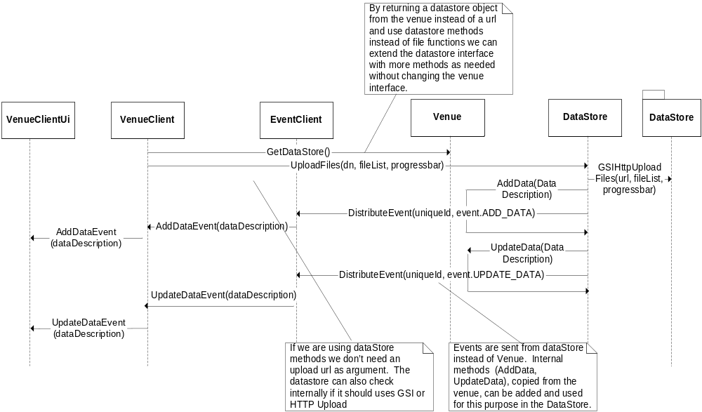
Figure 1 Upload files to venue’s DataStore

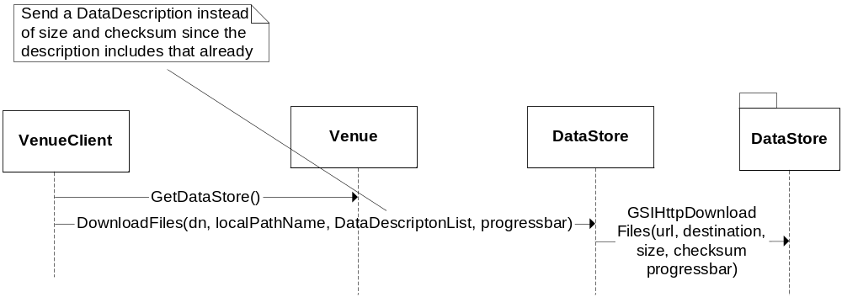
Figure 2 Download files from venue’s DataStore

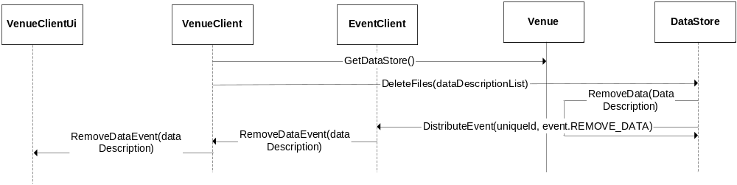
Figure 3 Remove files from venue's DataStore

Personal data
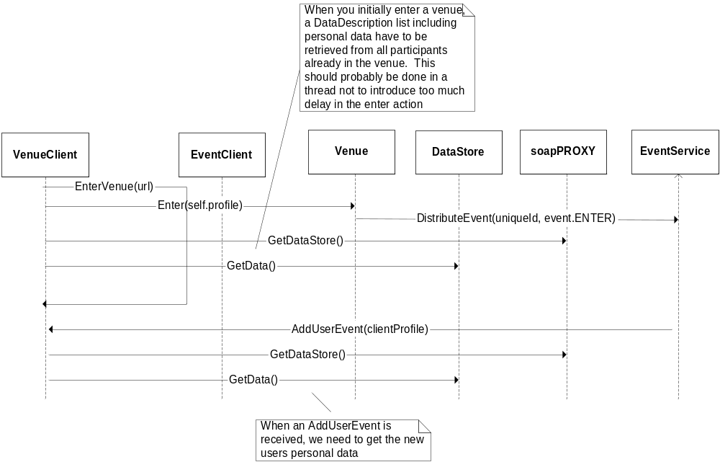
Figure 4 Handling personal data when new participant enters venue

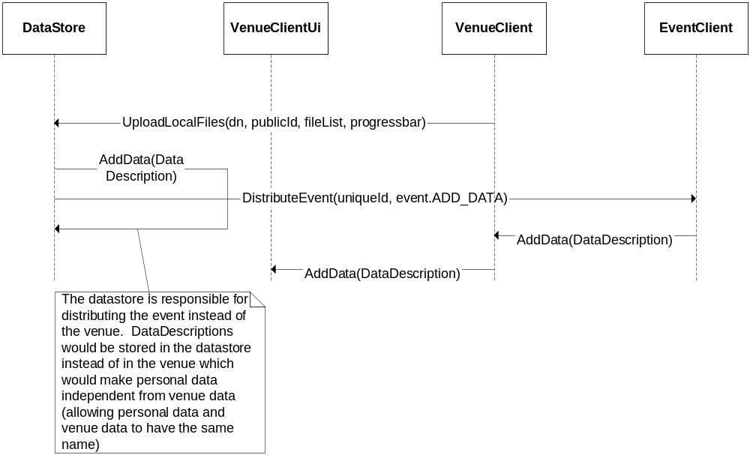
Figure 5 Add local files to personal DataStore located on the same computer

Solution 2

Create a class, DataDescriptionContainer, which manages a list of DataDescriptions. When the DataStore is created, the DataDescriptionContainer object would be sent in the callbackClass argument of the DataStore.

Motivation:

- Currently, two DataStore objects are used; one for personal data and one for venue data. A class that contains a DataStore object has to keep track of a DataDescription list, thus, duplicated lists need to be managed for each class having a DataStore. Each class that has a DataDescription list consequently need to make sure data also is persistent. By using a DataDescriptionContainer the duplicated code can be avoided for data description management and data persistence.

- Building a separate object, DataDescriptionContainer, instead of including the DataDescription list in the DataStore, makes the DataStore class independent of meta-data. The class can be extended later if needed and unnecessary errors that might occur when changing the DataStore class are also avoided.

- By not storing personal data in the venue, personal data is allowed to be named the same as venue data.

Suggested Methods for DataDescriptionContainer
void AddData(DataDescription)
void UpdateData(DataDescription)
void GetData(fileName)
string AsINIBlock()
DataDescription[] GetDataDescriptions()

Sequence Diagrams

Upload Venue Data
The VenueClient uses DataStore.UploadFiles, as shown in Figure 6, to upload a file to the venue. The DataStore calls the DataDescriptionContainer class, which adds a DataDescription to its list. Then, the Venue is notified and an event is sent to all clients connected to the venue. The only thing that the Venue methods AddData and UpdateData are responsible for is distributing events.

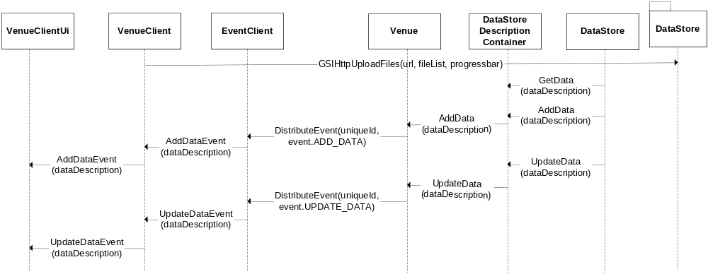
Figure 6 Upload data to venue

Download Venue Data
Same solution as currently implemented.

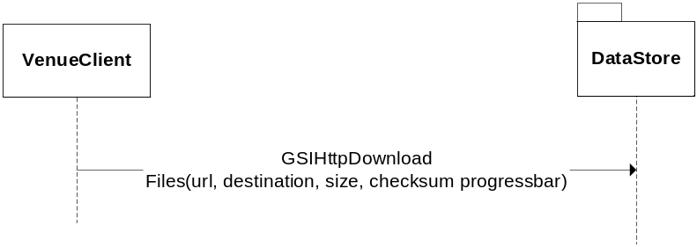
Figure 7 Download venue data

Upload Personal Data
The VenueClient calls DataStore.UploadLocalFiles, which uses the DataStoreDescriptionContainer’s AddData method. The event is sent from the VenueClient and not, as currently implemented, from the Venue.

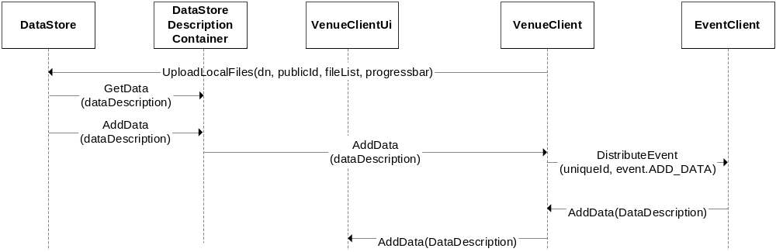
Figure 8 Upload local file to personal DataStore

New User Enters the Venue
Personal DataDescriptions are no longer available in the Venue and each user now has to query other participants for their data. Each participant therefore has to expose a SOAP method returning its list of DataDescriptions.

Scenario 1 - I enter the venue:
- I enter the venue
- The venue distributes an EnterVenueEvent to clients (including me)
- Distribute an AddDataEvent for all your personal data from your client
- Get personal data from all participants currently in the venue (ignore your own)
(* A user might exit the venue while I am trying to get his data which would result in a SOAP exception (try-except would do to catch the error)
(* A user might remove a personal file and distribute a RemoveDataEvent while I am trying to get his personal data. If this event is received before I have fetched personal data from that participant, the UI will not be coherent. This can be solved by using locks around the data fetch statement and the event methods in the VenueClient)
- Receive EnterEvent for me.

Scenario 2 - Somebody else enters the venue:
- Receive an EnterEvent
- Add user to UI
- Receive AddDataEvent for the new participants personal data

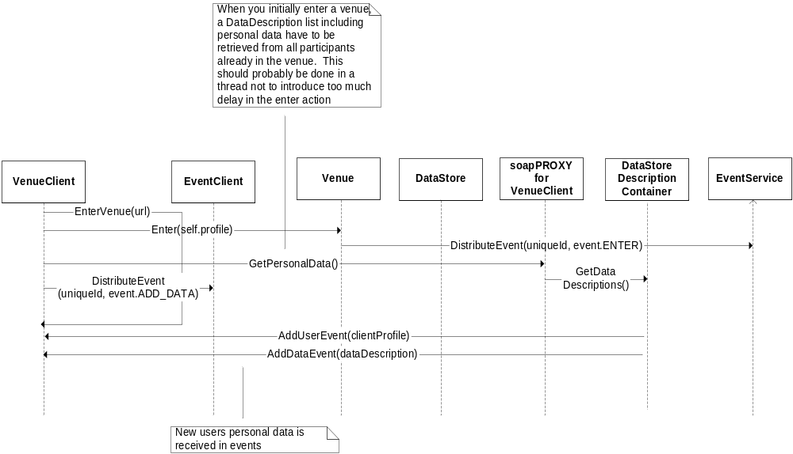
Figure 9 New user enters the venue

Solution 3
This solution is a combination of Solution 1, Solution 2, and current implementation.

Move management of DataDescriptions to a separate class, DataDescriptionContainer
If the DataDescriptionContainer is responsible for managing the list of DataDescriptions, persistence can be controlled by this class and we would avoid redundant code used to manage DataDescriptions needed in both VenueClient and Venue. The DataStore would create a DataDescriptionContainer and communicate with this class to maintain information about the data stored.

Remove the callback class
If we move the list of DataDescriptions from the Venue to the DataDescriptionContainer, Venue methods used to manage DataDescriptions such as AddData, GetData, and UpdataData should be moved from Venue to DataStoreContainer. Current DataStore code can then simply change venue callbacks (or VenueClient callbacks for personal data) to internal calls, which calls the DataDescriptionContainer instead.

Use the EventService/EventClient in the DataStore
The AddData, GetData, and UpdateData venue methods are responsible for sending events to clients connected to the venue. If we move those methods to the DataDescriptionContainer, a handle to the venue EventService or clients EventClient should be used in the DataDescriptionContainer to distribute appropriate events when descriptions are added/removed/changed.

Expose the DataStore via a SOAP interface
Make DataStore methods accessible via a SOAP interface to get information about data. Have a Venue.GetDataStoreLocation() or VenueClient.GetDataStoreLocation() method, which returns a URL we can use to establish a SOAP connection to the DataStore.

Suggested methods for the DataStore class:
void DeleteFiles(DataDescriptionList) - SOAP
[DataDescription] GetDataDescriptions() – SOAP
url GetUploadDescriptor() – SOAP
url GetDownloadDescriptor(fileName) - SOAP
void UploadLocalFiles(dn, publicId, fileList, progressbar) – Not SOAP DeleteLocalFiles(dn, fileList, progressbar) – Not SOAP
string AsINIBlock() – Not SOAP

DataStore module functions
Download and upload file operations need to be called from the VenueClient in order to access participants’ local file system. We can therefore not include these as methods in the DataStore SOAP interface. Clients would not get access to an actual venue DataStore object, instead Venue.GetDataStoreLocation() returns a url indicating where the DataStore SOAP interface is located. Therefore, DataStore file transfer functions are implemented as module functions in DataStore.py.

GSIHTTPDownloadFile(url, localPathName, size, checksum, progressbar)
GSIHTTPUploadFiles(url, fileList, progressbar)
HTTPDownloadFile(dn, url, localPathName, size, checksum, progressbar)
HTTPUploadFiles(dn, url, fileList, size, progressbar)

Suggested methods for the DataStoreContainer class
void AddData(dataDescription)
void UpdateData(dataDescription)
void GetData(fileName)
string AsINIBlock()
DataDescription[] GetDataDescriptions()

Venue Data
The VenueClient uses the module function GSIHTTPUploadFiles/ HTTPUploadFiles to upload files to venue DataStore, see Figure 10. From this function, the DataStore calls AddData on the DataDescriptionContainer class, which adds the new DataDescription to its list, then sends an ADD_DATA event to clients connected to the venue. Details about actions taken in the DataStore after the GSIHTTPUploadFiles/HTTPUploadFiles call is made are left out in the diagram below.

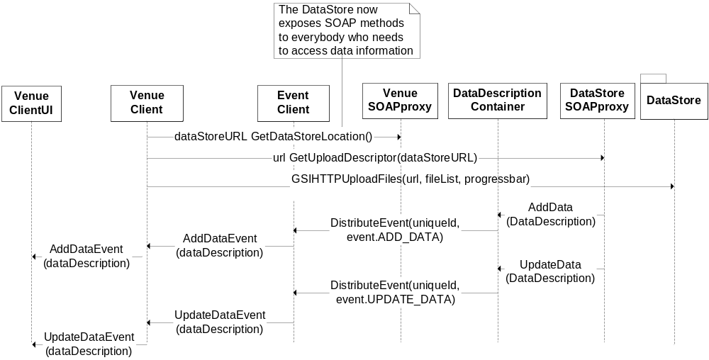
Figure 10 Upload venue data

When a participant wants to download files, it requests the downloadDescriptor from the DataStore, then calls the GSIHTTPDownload/ HTTPDownloadFile module function using the descriptor received, see Figure 11.

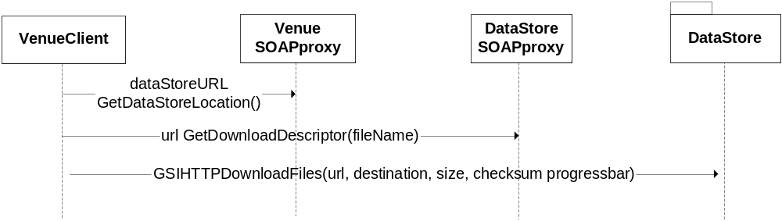
Figure 11 Download venue data

Personal Data
The same DataStore object and module are used both for venue data and personal data.

Upload Personal Data
The participant having the personal data store adds files with just a local, UploadLocalFiles call, to the DataStore object created in the client. The DataDescritionContainer is responsible for distributing events via the EventClient.

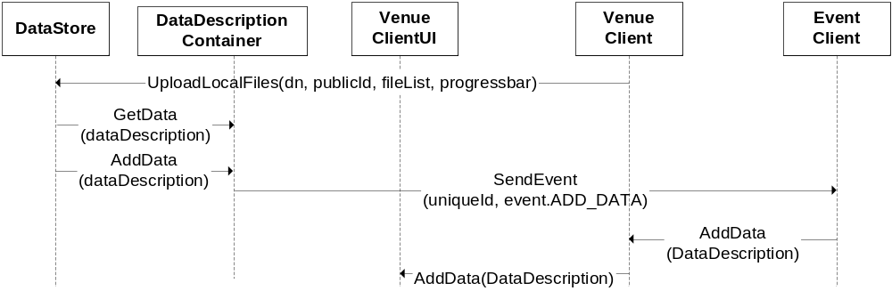
Figure 12 Add personal data

Download Personal Data
Participants in the venue can chose to download data from other participants’ personal data. This is done in the same way as with venue data. The ClientProfiles contain a URL where participants’ personal DataStore is located. By using the SOAP interface of the client, as shown in Figure 13, the DataStore interface can be identified and information which url to use for GSIHTTPDownload HTTPDownloadFile is returned by the GetDownloadDescriptor method.

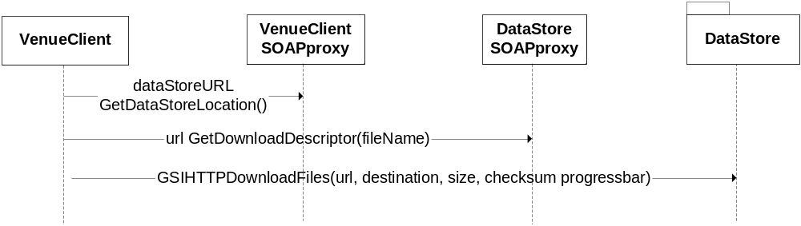
Figure 13 Get data from remote client's personal DataStore

New user enters venue
A new participants entering a venue needs to get information about personal data from all participants currently in the venue. We could let the new participant grab all other participants’ personal data when entering, but this could introduce a huge delay if a lot of personal data is present. A better solution is to just get personal data the first time a user is trying to view a participant’s data. The call only need to happen once, after the GetDataDecriptions method is called the client would react on events (ADD_DATA, REMOVE_DATA etc.) from clients.

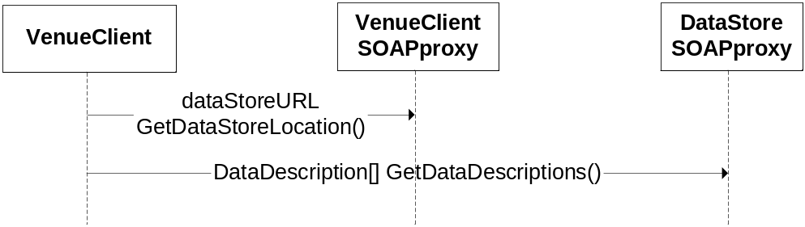
Figure 14 Initial personal data request

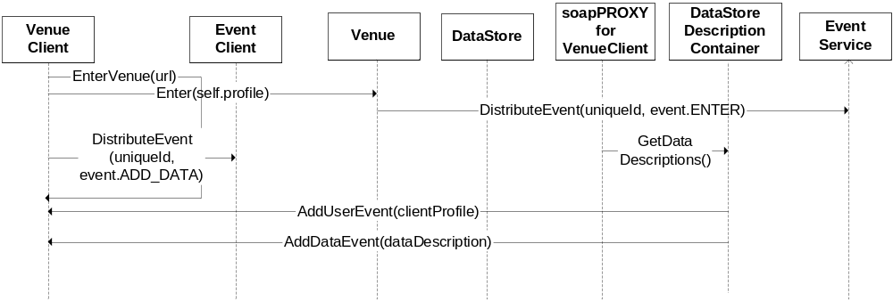
Figure 15 After the initial personal data request is made, updates are done via events

NOTE:
I am afraid a race condition may appear when a user tries to get data from a personal DataStore since possible events and the GetDataDescriptions SOAP call are competing with each other.

