Suggestions for data storage improvements

Solution1

Move management of DataDescriptions to the DataStore.
If the DataStore is responsible for managing the list of DataDescriptions, persistence can be controlled by the DataStore and we would avoid redundant code used to manage DataDescriptions used by both VenueClient and Venue.

Remove the callback class
If we move the list of DataDescriptions from the Venue to the DataStore, Venue methods used to manage DataDescriptions such as AddData, GetData, and UpdataData should be moved from Venue to DataStore. Current DataStore code can then simply change venue callbacks (or VenueClient callbacks for personal data) to internal calls.

Use the EventClient in the DataStore
The AddData, GetData, and UpdateData venue methods are responsible for sending events to clients connected to the venue. If we move those methods to the DataStore an EventClient should be used in the DataStore to distribute appropriate events to clients. The EventClient would send events but not register callbacks.

Use the DataStore as an Object
We might want to use the DataStore consistently as an object with interface methods. If the DataStore would be used as an object, we can have a Venue.GetDataStore() method and then call DataStore methods directly, and the Venue.GetUploadDescriptor method can disappear. Then we don’t need to care about which transfer engine or url is used when uploading/downloading, that can be handled internally in the DataStore methods. (This might just be my preference and involves more changes than we would like, I just like the idea of always calling a datastore object’s methods as we are for DeleteFiles and UploadLocalFiles).

SHOULD INTERFACE METHODS BE EXPOSED USING SOAP?

Suggested methods for the DataStore:
void UploadFiles(dn, fileList, progressbar)
void DownloadFiles(dn, localPathName, DataDescriptionList, progressbar)
void DeleteFiles(DataDescriptionList) (SOAP?)
[DataDescription] GetData() (SOAP?)
void UploadLocalFiles(dn, publicId, fileList, progressbar)

Sequence Diagrams

Venue data
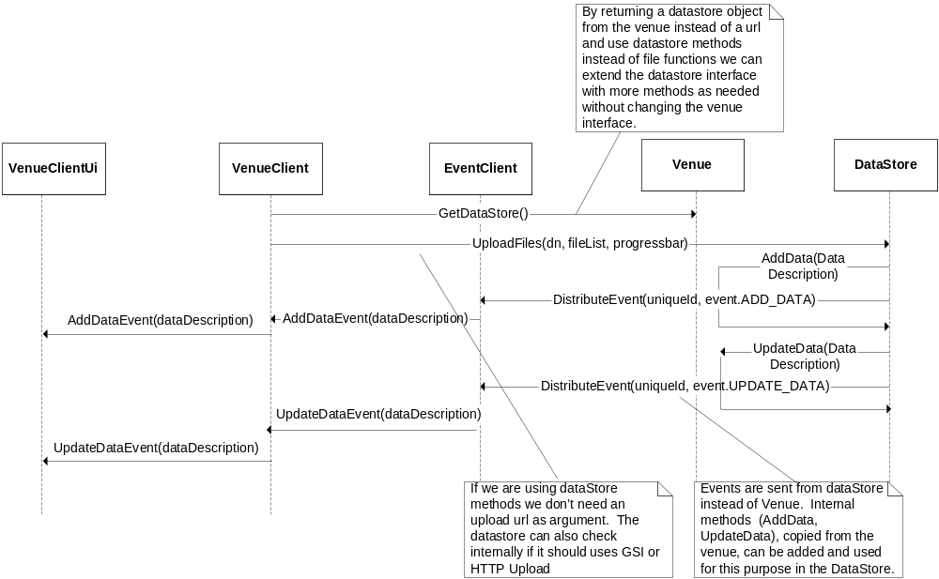
Figure 1 Upload files to venue’s DataStore

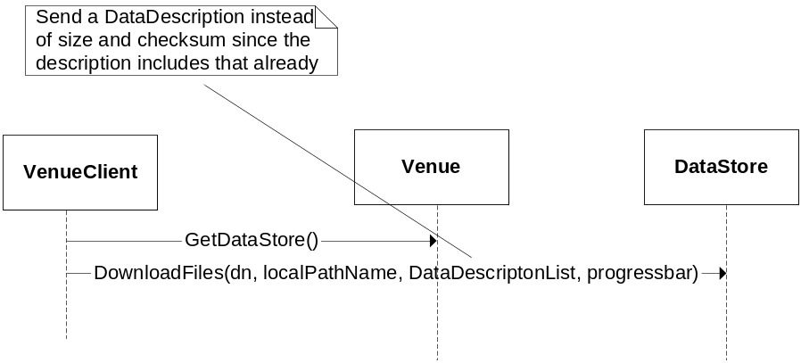
Figure 2 Download files from venue’s DataStore

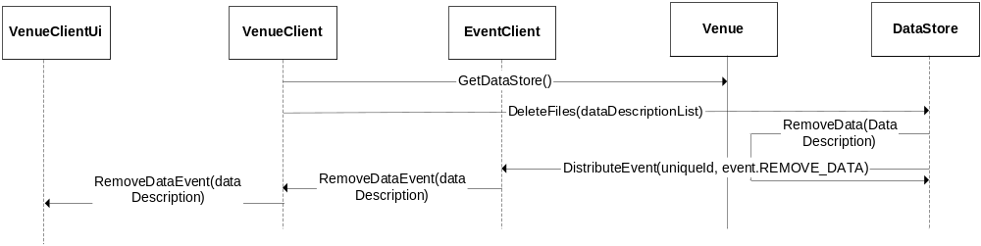
Figure 3 Remove files from venue's DataStore

Personal data
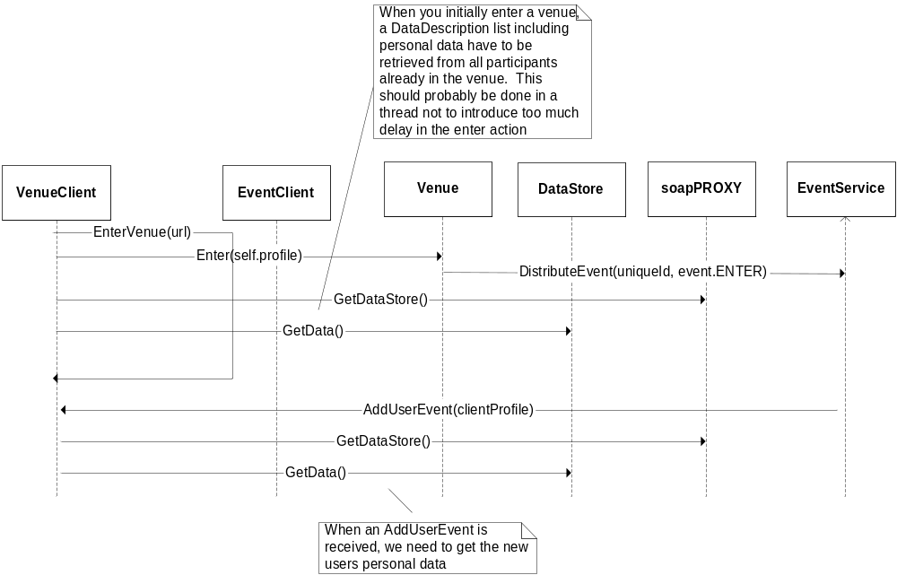
Figure 4 Handling personal data when new participant enters venue

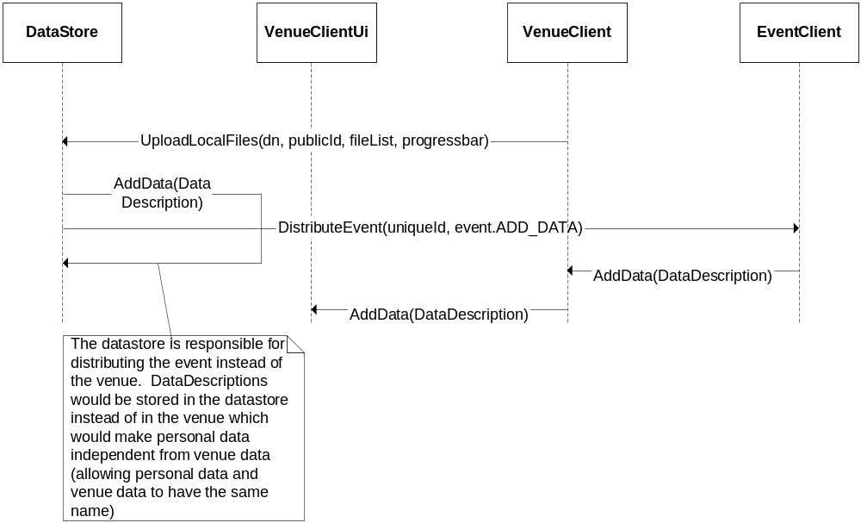
Figure 5 Add local files to personal DataStore located on the same computer

Solution 2

Create a class, DataDescriptionContainer, which manages a list of DataDescriptions. When the DataStore is created, the DataDescriptionContainer object would be sent in the callbackClass argument of the DataStore.

Motivation:

- Currently, two DataStore objects are used; one for personal data and one for venue data. A class that contains a DataStore object has to keep track of a DataDescription list, thus, duplicated lists need to be managed for each class having a DataStore. Each class that has a DataDescription list consequently need to make sure data also is persistent. By using a DataDescriptionContainer the duplicated code can be avoided for data description management and data persistence.

- Building a separate object, DataDescriptionContainer, instead of including the DataDescription list in the DataStore, makes the DataStore class independent of meta-data. The class can be extended later if needed and unnecessary errors that might occur when changing the DataStore class are also avoided.

- By not storing personal data in the venue, personal data is allowed to be named the same as venue data.

Suggested Methods for DataDescriptionContainer
void AddData(DataDescription)
void UpdateData(DataDescription)
void GetData(fileName)
string AsINIBlock()
DataDescription[] GetDataDescriptions()

Sequence Diagrams

Upload Venue Data
The VenueClient uses DataStore.UploadFiles, as shown in Figure 6, to upload a file to the venue. The DataStore calls the DataDescriptionContainer class, which adds a DataDescription to its list. Then, the Venue is notified and an event is sent to all clients connected to the venue. The only thing that the Venue methods AddData and UpdateData are responsible for is distributing events.

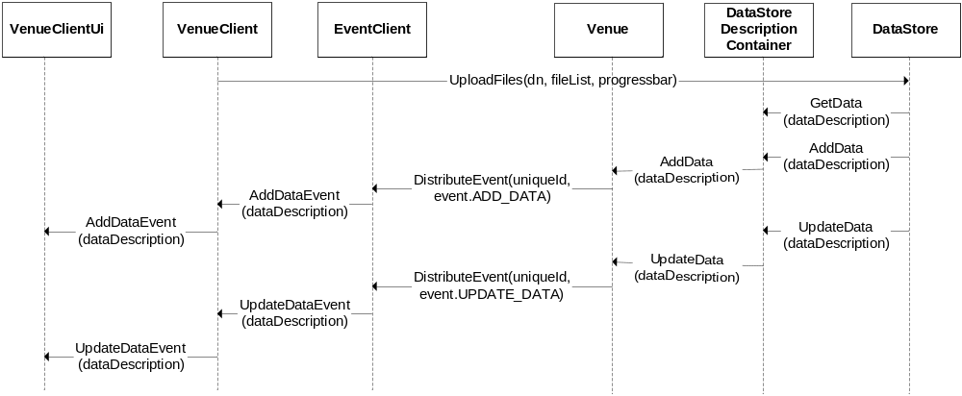
Figure 6 Upload data to venue

Download Venue Data
Same solution as currently implemented.

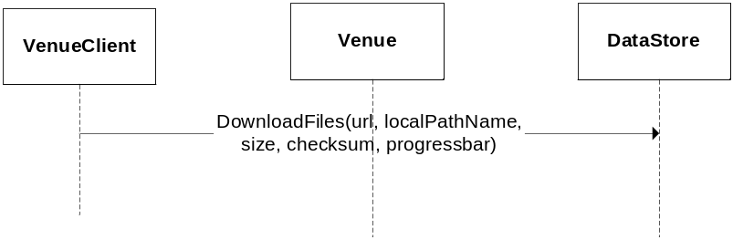
Figure 7 Download venue data

Upload Personal Data
The VenueClient calls DataStore.UploadLocalFiles, which uses the DataStoreDescriptionContainer’s AddData method. The event is sent from the VenueClient and not, as currently implemented, from the Venue.

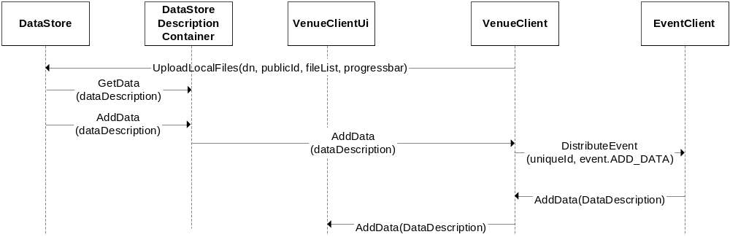
Figure 8 Upload local file to personal DataStore

New User Enters the Venue
Personal DataDescriptions are no longer available in the Venue and each user now has to query other participants for their data. Each participant therefore has to expose a SOAP method returning its list of DataDescriptions.

Scenario 1 - I enter the venue:
- I enter the venue
- The venue distributes an EnterVenueEvent to clients (including me)
- Distribute an AddDataEvent for all your personal data
- Get personal data from all participants currently in the venue (ignore your own)
(* A user might exit the venue while I am trying to get his data which would result in a SOAP exception (try-except would do to catch the error)
(* A user might remove a personal file and distribute a RemoveDataEvent while I am trying to get his personal data. If this event is received before I have fetched personal data from that participant, the UI will not be coherent. This can be solved by using locks around the data fetch statement and the event methods)
- Receive EnterEvent for me.
- Add your own personal data (not using SOAP) if the clientProfile received from the EnterEvent is my profile.

Scenario 2 - Somebody else enters the venue:
- Receive an EnterEvent
- Add user to UI
- Receive AddDataEvent for the new participants personal data

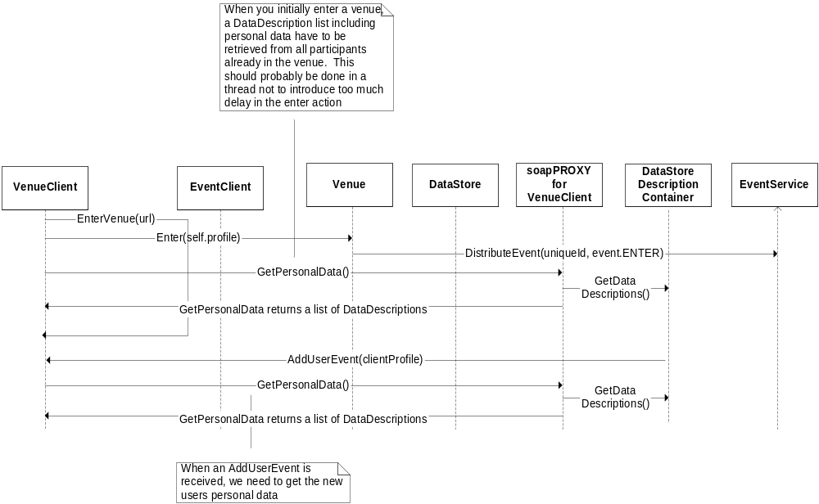
Figure 9 New user enters the venue

