Suggestions for data storage improvements

Move management of DataDescriptions to the DataStore.
If the DataStore is responsible for managing the list of DataDescriptions, persistence can be controlled by the DataStore and we would avoid redundant code used to manage DataDescriptions used by both VenueClient and Venue.

Remove the callback class
If we move the list of DataDescriptions from the Venue to the DataStore, Venue methods used to manage DataDescriptions such as AddData, GetData, and UpdataData should be moved from Venue to DataStore. Current DataStore code can then simply change venue callbacks (or VenueClient callbacks for personal data) to internal calls.

Use the EventClient in the DataStore
The AddData, GetData, and UpdateData venue methods are responsible for sending events to clients connected to the venue. If we move those methods to the DataStore an EventClient should be used in the DataStore to distribute appropriate events to clients. The EventClient would send events but not register callbacks.

Use the DataStore as an Object
We might want to use the DataStore consistently as an object with interface methods. If the DataStore would be used as an object, we can have a Venue.GetDataStore() method and then call DataStore methods directly, and the Venue.GetUploadDescriptor method can disappear. Then we don’t need to care about which transfer engine or url is used when uploading/downloading, that can be handled internally in the DataStore methods. (This might just be my preference and involves more changes than we would like, I just like the idea of always calling a datastore object’s methods as we are for DeleteFiles and UploadLocalFiles).

SHOULD INTERFACE METHODS BE EXPOSED USING SOAP?

Suggested methods for the DataStore:
void UploadFiles(dn, fileList, progressbar)
void DownloadFiles(dn, localPathName, DataDescriptionList, progressbar)
void DeleteFiles(DataDescriptionList) (SOAP?)
[DataDescription] GetData() (SOAP?)
void UploadLocalFiles(dn, publicId, fileList, progressbar)

Sequence Diagrams

Venue data
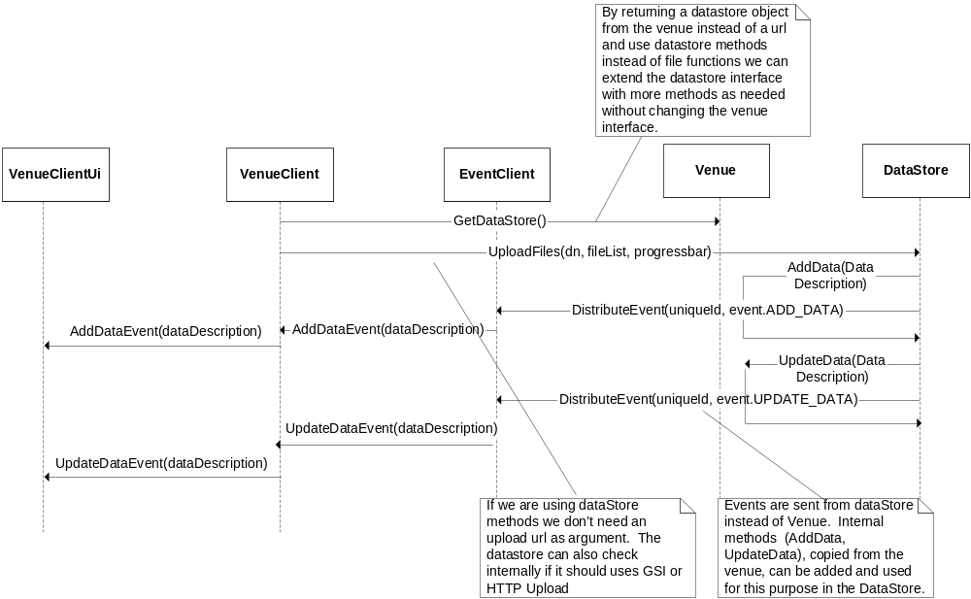
Figure 1 Upload files to venue’s DataStore

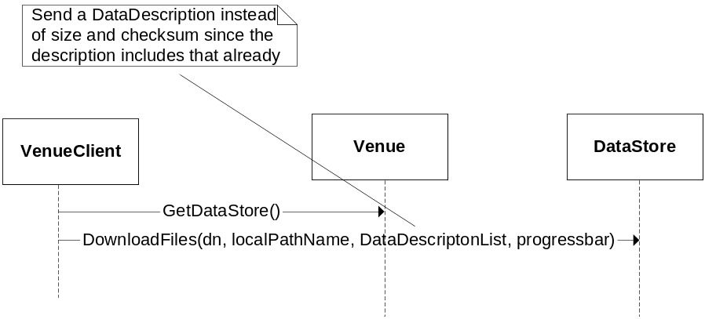
Figure 2 Download files from venue’s DataStore

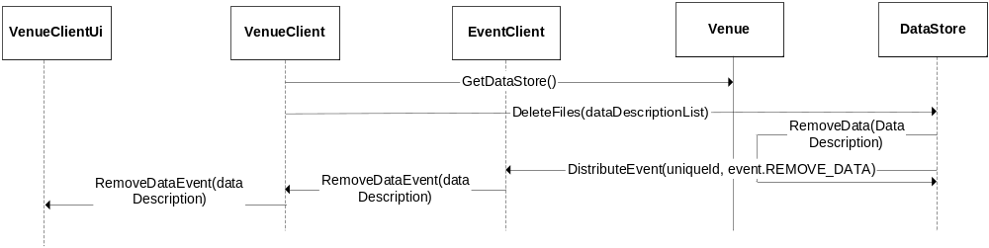
Figure 3 Remove files from venue's DataStore

Personal data
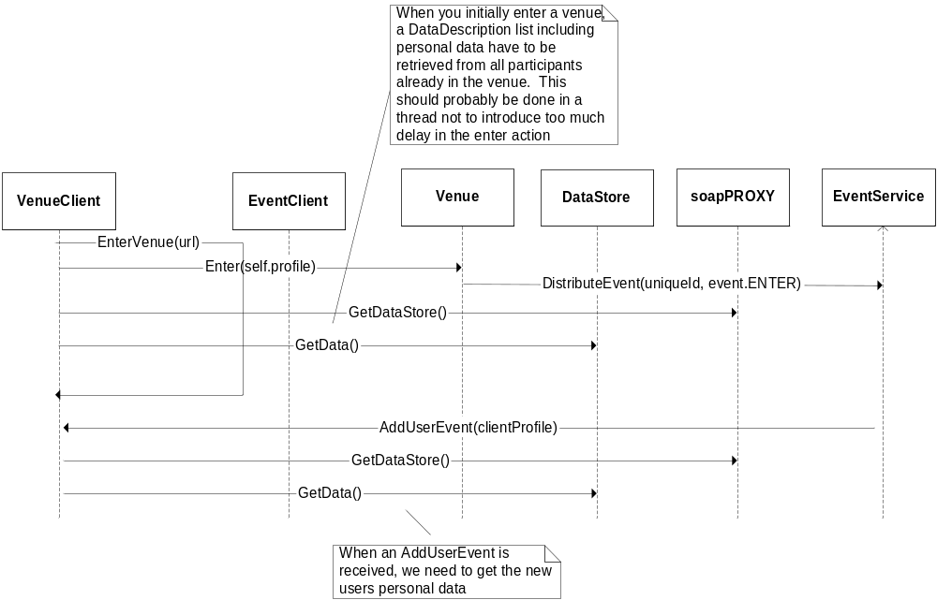
Figure 4 Handling personal data when new participant enters venue

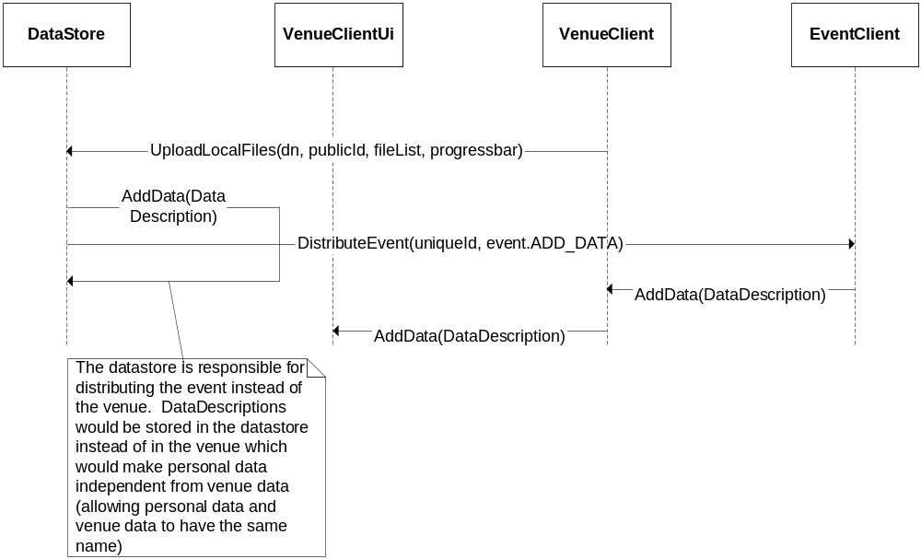
Figure 5 Add local files to personal DataStore located on the same computer

